Name: BAO, Qingjun

ID Number: 2398022

Date: 2023/05/16

**Acronym List**

# How Much Memory or RAM Should My Computer Have?RAM

RAM is a common computing acronym that stands for **Random-Access Memory**. Sometimes it’s called PC memory or just memory. In essence, RAM is your computer or laptop’s short-term memory. It’s where the data is stored that your computer processor needs to run your applications and open your files.

Inside your computer, RAM typically comes in the form of a rectangular flat circuit board with memory chips attached, also referred to as a memory module. Computers typically come with at least two RAM modules with room to add more, if needed. These RAM modules are critical components that work hand in hand with your computer’s central processing unit (CPU) and must be working optimally for you to have a good experience.

<https://www.intel.ca/content/www/ca/en/tech-tips-and-tricks/computer-ram.html>

# ROM

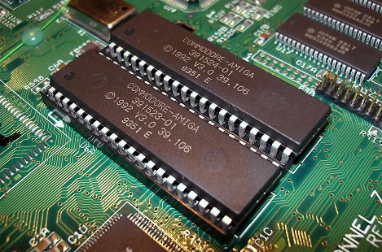**Read-only memory** (ROM) is a type of non-volatile memory used in computers and other electronic devices. Data stored in ROM cannot be electronically modified after the manufacture of the memory device. Read-only memory is useful for storing software that is rarely changed during the life of the system, also known as firmware. Software applications (like video games) for programmable devices can be distributed as plug-in cartridges containing ROM.

<https://en.wikipedia.org/wiki/Read-only_memory>

# https://upload.wikimedia.org/wikipedia/commons/thumb/d/dc/Intel_80486DX2_top.jpg/1024px-Intel_80486DX2_top.jpgCPU

**Central Processing Unit** (CPU)—also called a central processor or main processor—is the most important processor in a given computer. Its electronic circuitry executes instructions of a computer program, such as arithmetic, logic, controlling, and input/output (I/O) operations. This role contrasts with that of external components, such as main memory and I/O circuitry, and specialized coprocessors such as graphics processing units (GPUs).

<https://en.wikipedia.org/wiki/Central_processing_unit>

# MB

MB (**MegaByte)** One million bytes (1,000,000 bytes or 1,048,576 bytes).

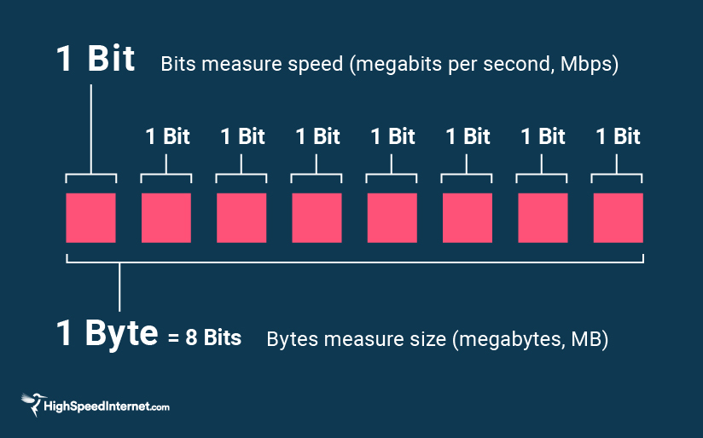

https://www.pcmag.com/encyclopedia/term/mb

# GB

GB (**GigaByte**) One billion bytes (technically 1,073,741,824 bytes).

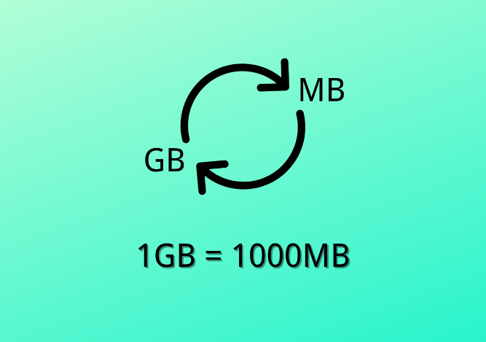

<https://www.pcmag.com/encyclopedia/term/gb>

# TB

**TB (TeraByte**) One trillion bytes (technically 1,099,511,627,776 bytes)

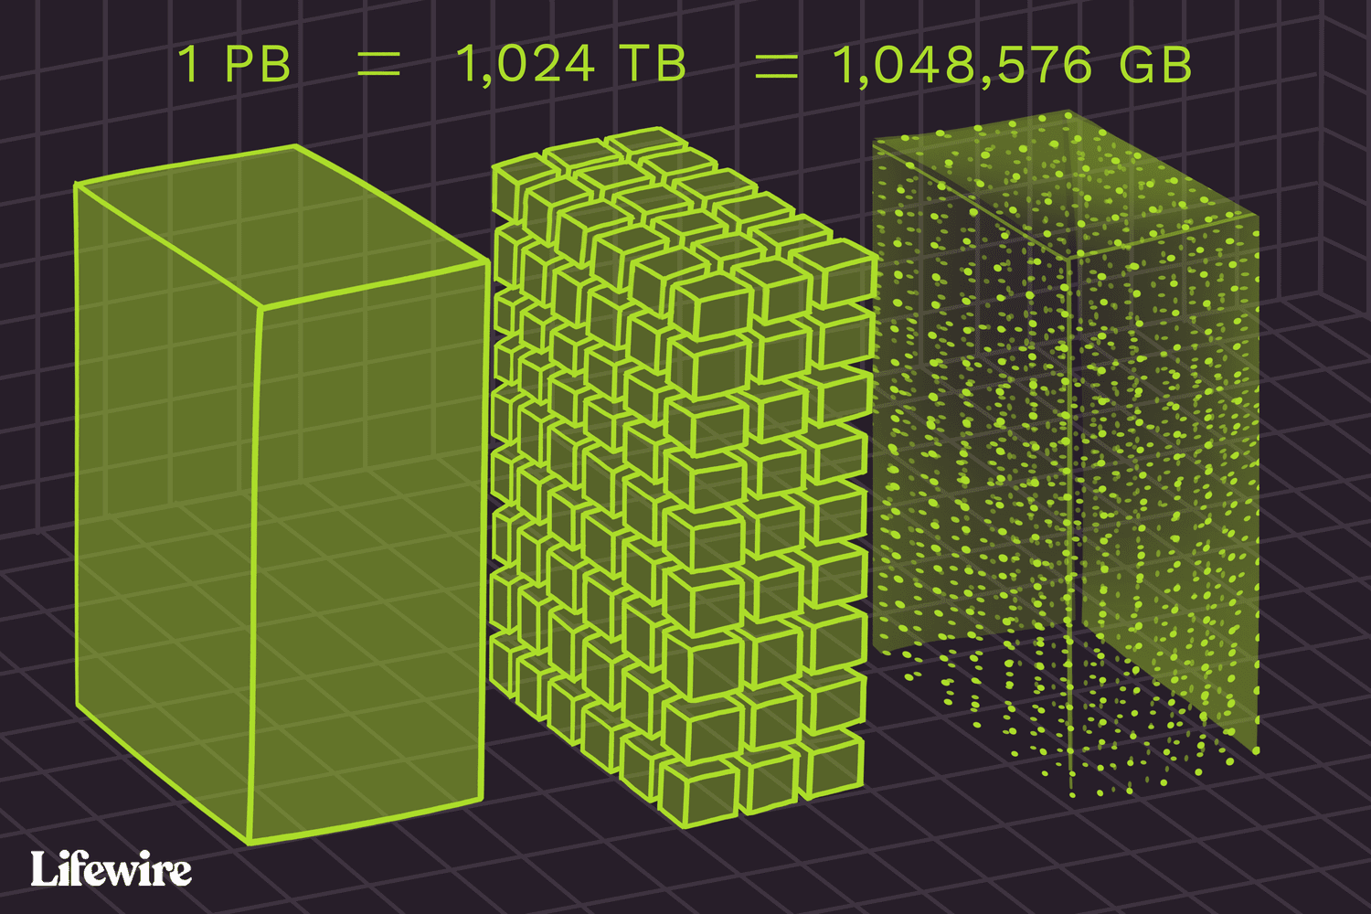

https://www.pcmag.com/encyclopedia/term/tb

# PB

A **PetaByte** is a measure of memory or data storage capacity that is equal to 2 to the 50th power of bytes. There are 1,024 terabytes (TB) in a petabyte and approximately 1,024 PB make up one exabyte.

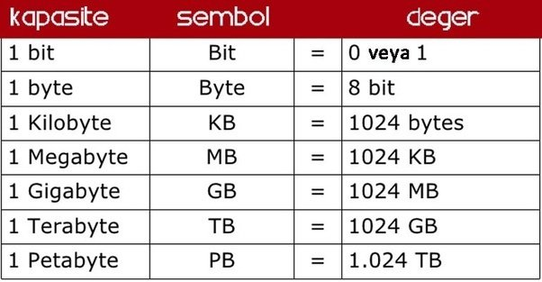

<https://www.techtarget.com/searchstorage/definition/petabyte>

# Data Networks classification by spatial scope.svgLAN

**Local Area Network** (LAN) is a computer network that interconnects computers within a limited area such as a residence, school, laboratory, university campus or office building. By contrast, a wide area network (WAN) not only covers a larger geographic distance, but also generally involves leased telecommunication circuits.

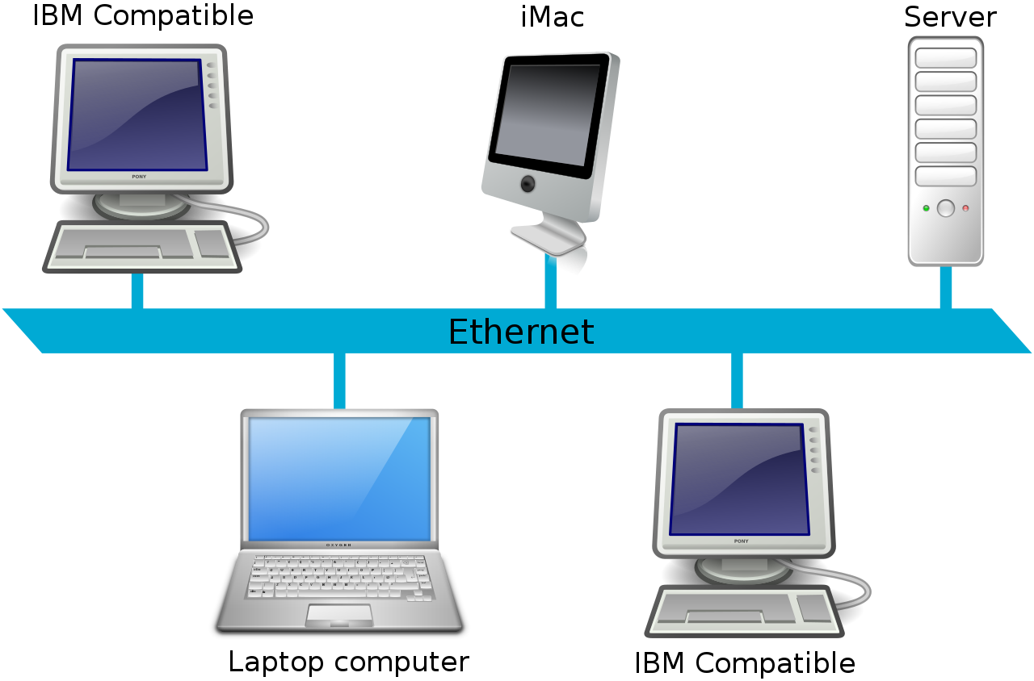

<https://en.wikipedia.org/wiki/Local_area_network>

# LCD

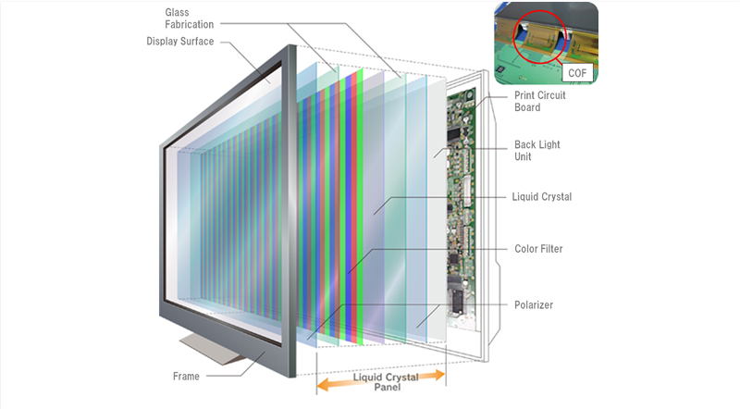**Liquid-Crystal Display (LCD)** is a flat-panel display or other electronically modulated optical device that uses the light-modulating properties of liquid crystals combined with polarizers. Liquid crystals do not emit light directly but instead use a backlight or reflector to produce images in color or monochrome. LCDs are available to display arbitrary images (as in a general-purpose computer display) or fixed images with low information content, which can be displayed or hidden. For instance: preset words, digits, and seven-segment displays, as in a digital clock, are all good examples of devices with these displays. They use the same basic technology, except that arbitrary images are made from a matrix of small pixels, while other displays have larger elements. LCDs can either be normally on (positive) or off (negative), depending on the polarizer arrangement. For example, a character positive LCD with a backlight will have black lettering on a background that is the color of the backlight, and a character negative LCD will have a black background with the letters being of the same color as the backlight. Optical filters are added to white on blue LCDs to give them their characteristic appearance.

<https://en.wikipedia.org/wiki/Liquid-crystal_display>

# UX

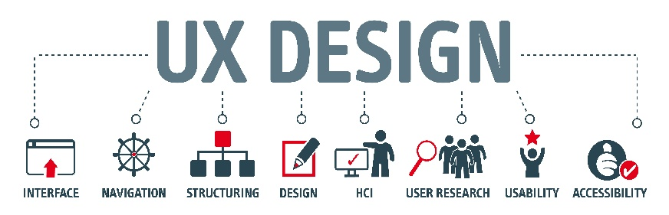**User Experience (UX**) is how a user interacts with and experiences a product, system or service. It includes a person's perceptions of utility, ease of use, and efficiency. Improving user experience is important to most companies, designers, and creators when creating and refining products because negative user experience can diminish the use of the product and, therefore, any desired positive impacts; conversely, designing toward profitability often conflicts with ethical user experience objectives and even causes harm. User experience is subjective. However, the attributes that make up the user experience are objective.

<https://en.wikipedia.org/wiki/User_experience>

# UI

**User Interface (UI**) is the space where interactions between humans and machines occur. The goal of this interaction is to allow effective operation and control of the machine from the human end, while the machine simultaneously feeds back information that aids the operators' decision-making process. Examples of this broad concept of user interfaces include the interactive aspects of computer operating systems, hand tools, heavy machinery operator controls and process controls. The design considerations applicable when creating user interfaces are related to, or involve such disciplines as, ergonomics and psychology.

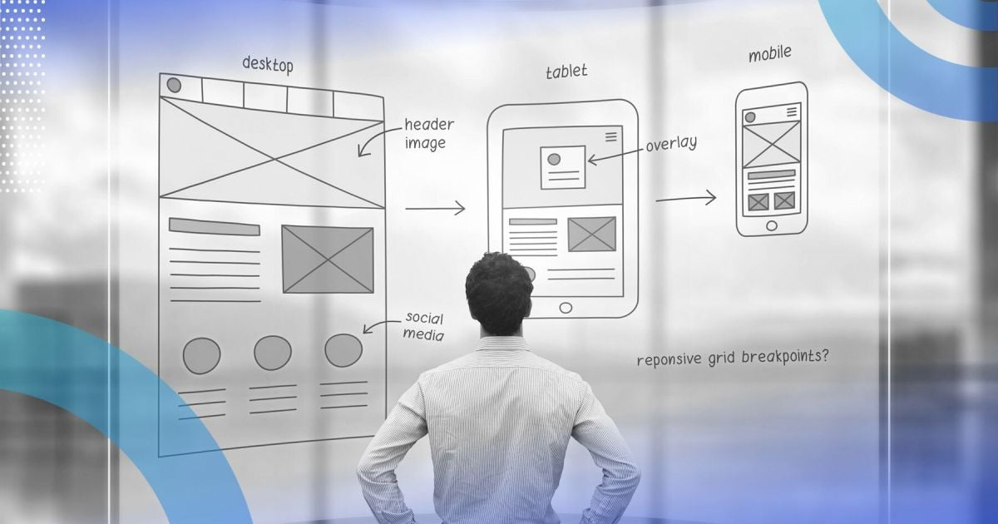

<https://en.wikipedia.org/wiki/User_interface>

# IT

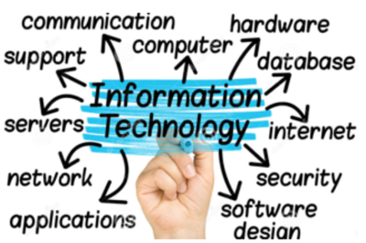**Information Technology (IT)** is the use of computers to create, process, store, retrieve and exchange all kinds of data and information. IT forms part of information and communications technology (ICT). An information technology system (IT system) is generally an information system, a communications system, or, more specifically speaking, a computer system — including all hardware, software, and peripheral equipment — operated by a limited group of IT users.

<https://en.wikipedia.org/wiki/Information_technology>

# MIS

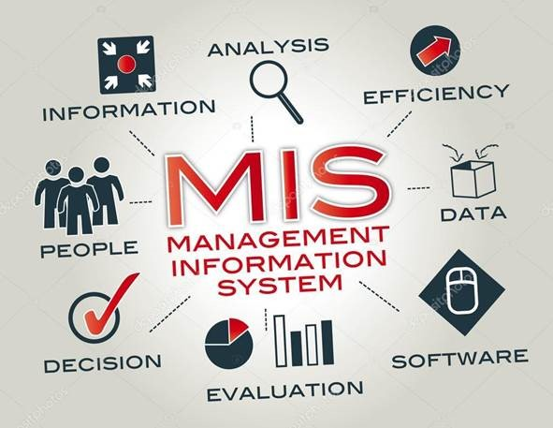**Management Information System (MIS)** is an information system used for decision-making, and for the coordination, control, analysis, and visualization of information in an organization. The study of the management information systems involves people, processes and technology in an organizational context.

<https://en.wikipedia.org/wiki/Management_information_system>

# GUI

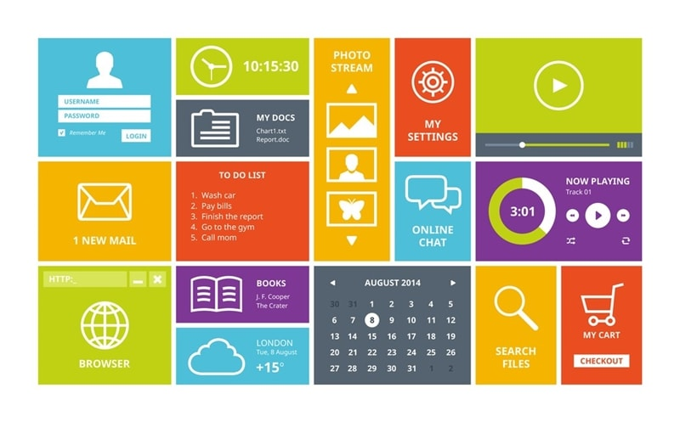**Graphical User Interface, GUI** is a form of user interface that allows users to interact with electronic devices through graphical icons and audio indicator such as primary notation, instead of text-based UIs, typed command labels or text navigation. GUIs were introduced in reaction to the perceived steep learning curve of command-line interfaces (CLIs), which require commands to be typed on a computer keyboard.

<https://en.wikipedia.org/wiki/Graphical_user_interface>

# BIT

(**BI**nary digi**T**) The smallest element of computer storage. The bit is a single digit in a binary number containing only 0s and 1s. Physically the bit is a transistor and capacitor in a RAM cell, a magnetic domain on disk or tape, a cell in a solid state drive (SSD), a spot on optical media or a voltage pulsing through a circuit.

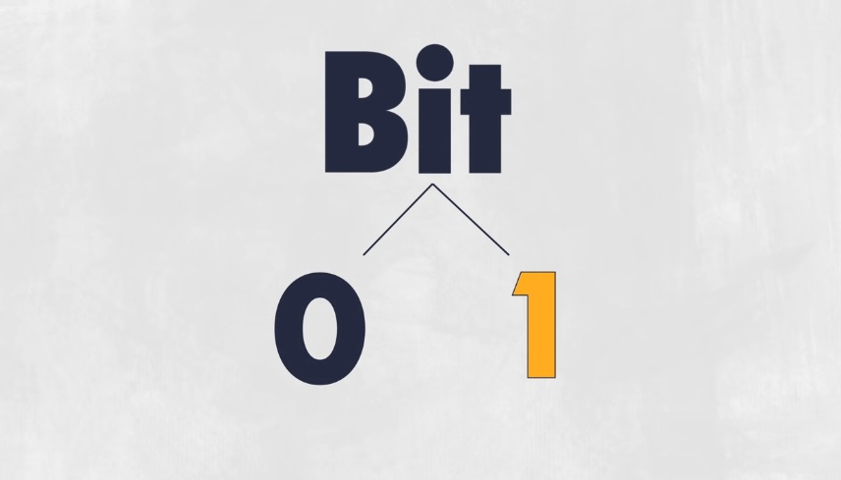

<https://www.pcmag.com/encyclopedia/term/bit>

# How to Send an Email as a Blind Copy (Gmail Cc and Bcc)?BCC

**Blind Carbon Copy** (abbreviated Bcc) allows the sender of a message to conceal the person entered in the Bcc field from the other recipients. This concept originally applied to paper correspondence and now also applies to email.

<https://en.wikipedia.org/wiki/Blind_carbon_copy>

# EDI

**Electronic Data Interchange (EDI)** is the concept of businesses electronically communicating information that was traditionally communicated on paper, such as purchase orders, advance ship notices, and invoices. Technical standards for EDI exist to facilitate parties transacting such instruments without having to make special arrangements.

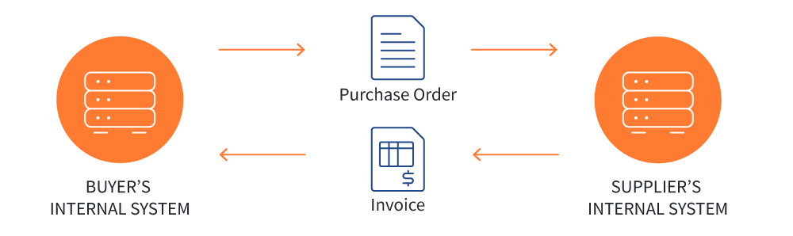

<https://en.wikipedia.org/wiki/Electronic_data_interchange>

<https://www.pcmag.com/encyclopedia/term/EDI>

<https://www.edibasics.com/what-is-edi/>

# ISP

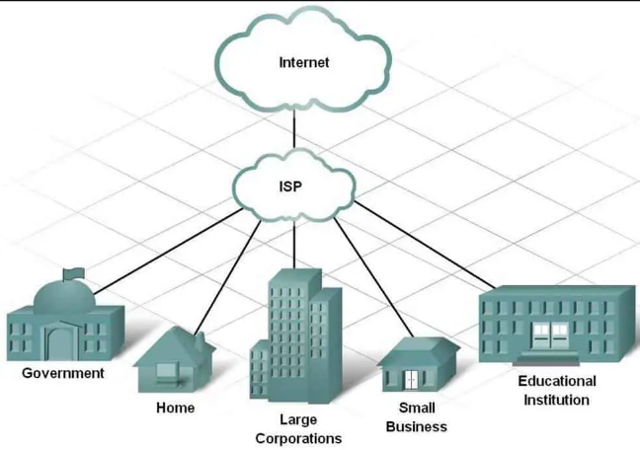**Internet Service Provider (ISP)** is an organization that provides services for accessing, using, managing, or participating in the Internet. ISPs can be organized in various forms, such as commercial, community-owned, non-profit, or otherwise privately owned.

<https://en.wikipedia.org/wiki/Internet_service_provider>

# CMS

content management system (CMS) is computer software used to manage the creation and modification of digital content (content management). A CMS is typically used for enterprise content management (ECM) and web content management (WCM).

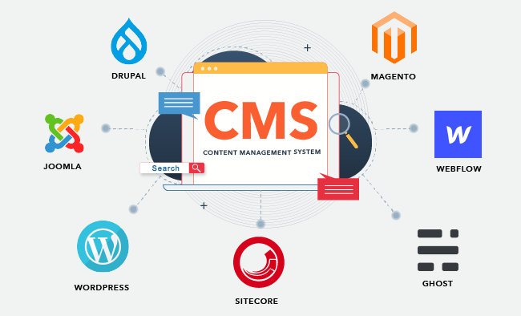

<https://en.wikipedia.org/wiki/Content_management_system>

# URI

**(Uniform Resource Identifier**) The addressing technology for identifying resources on the Internet (or private intranet). The URI that is most widely known is the URL, which is the address of a Web page and technically an "HTTP URI." However, the Internet serves many functions (see below). See HTTP, URL and URN.

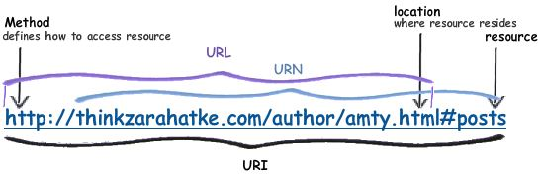

<https://www.pcmag.com/encyclopedia/term/uri>

# SEO

**Search Engine Optimization** (SEO) is the process of improving the quality and quantity of website traffic to a website or a web page from search engines. SEO targets unpaid traffic (known as "natural" or "organic" results) rather than direct traffic or paid traffic. Unpaid traffic may originate from different kinds of searches, including image search, video search, academic search, news search, and industry-specific vertical search engines.

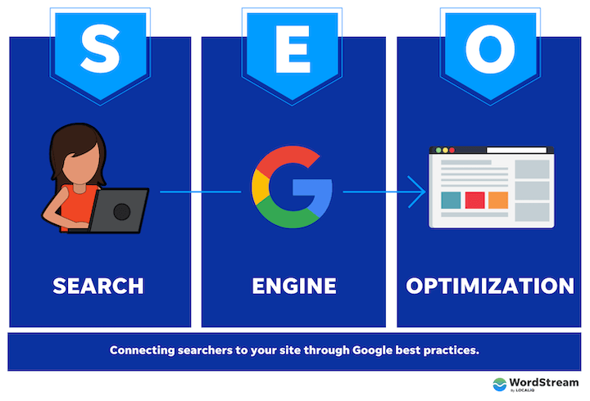

<https://en.wikipedia.org/wiki/Search_engine_optimization>

# HTML - GeeksforGeeksHTML

HyperText Markup Language or HTML is the standard markup language for documents designed to be displayed in a web browser. It is often assisted by technologies such as Cascading Style Sheets (CSS) and scripting languages such as JavaScript.

<https://en.wikipedia.org/wiki/HTML>

# HTTPS

Hypertext Transfer Protocol Secure (HTTPS) is an extension of the Hypertext Transfer Protocol (HTTP). It uses encryption for secure communication over a computer network, and is widely used on the Internet. In HTTPS, the communication protocol is encrypted using Transport Layer Security (TLS) or, formerly, Secure Sockets Layer (SSL). The protocol is therefore also referred to as HTTP over TLS, or HTTP over SSL.

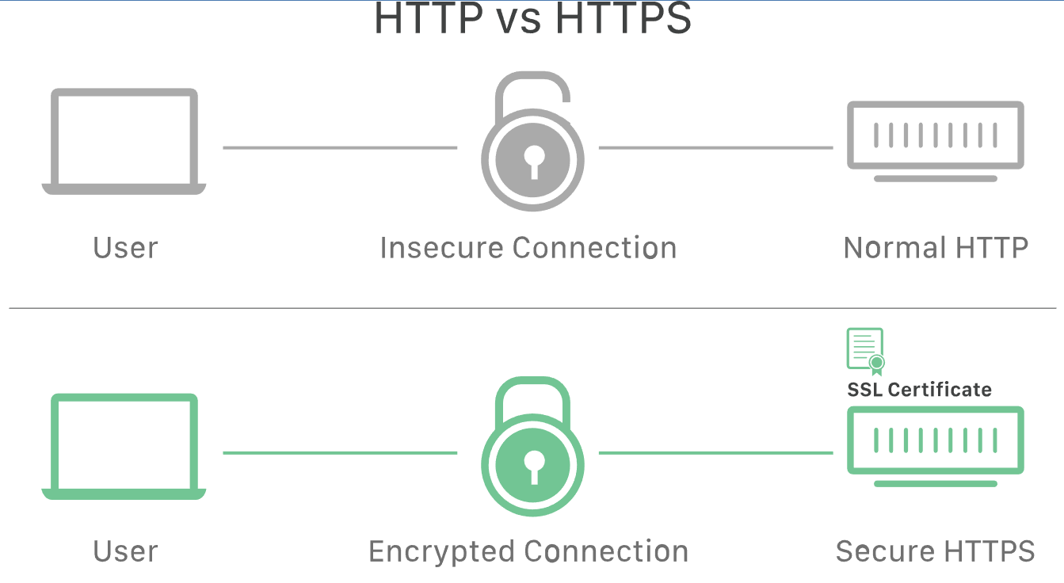

<https://en.wikipedia.org/wiki/HTTPS>

# BYOD

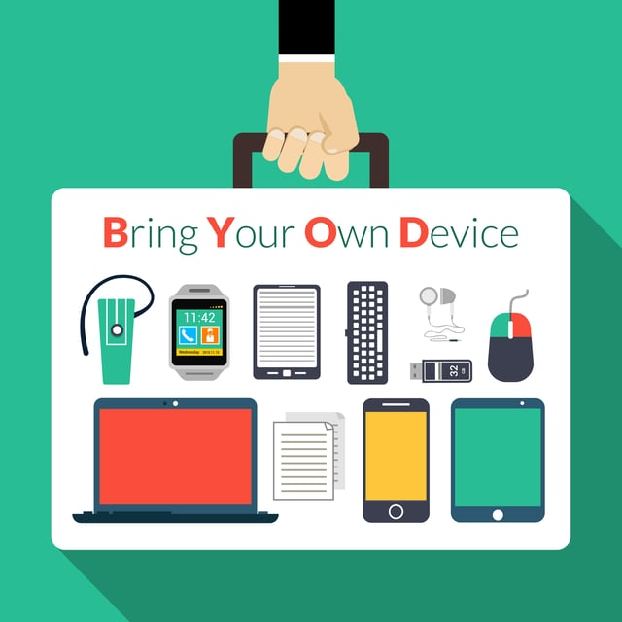**Bring Your Own Device** also called bring your own technology (BYOT), bring your own phone (BYOP), and bring your own personal computer (BYOPC)—refers to being allowed to use one's personally owned device, rather than being required to use an officially provided device.

https://en.wikipedia.org/wiki/Bring_your_own_device

# URL

**Uniform Resource Locator (URL),** colloquially termed a web address, is a reference to a web resource that specifies its location on a computer network and a mechanism for retrieving it. A URL is a specific type of Uniform Resource Identifier (URI), although many people use the two terms interchangeably. URLs occur most commonly to reference web pages (HTTP/HTTPS) but are also used for file transfer (FTP), email (mailto), database access (JDBC), and many other applications.

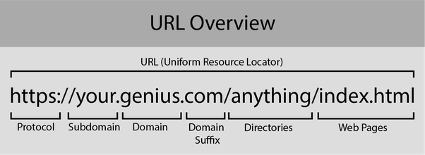

<https://en.wikipedia.org/wiki/URL>

# NMS

**NetWare Management System**. NMS was SNMP-based network management software from Novell for monitoring and controlling NetWare networks. NMS was superseded by ManageWise.

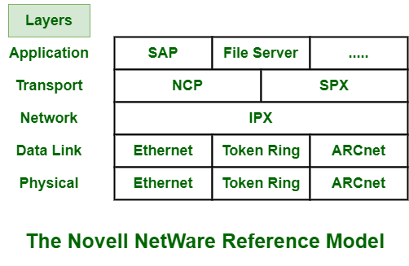

<https://www.pcmag.com/encyclopedia/term/netware-management-system>

# HDD

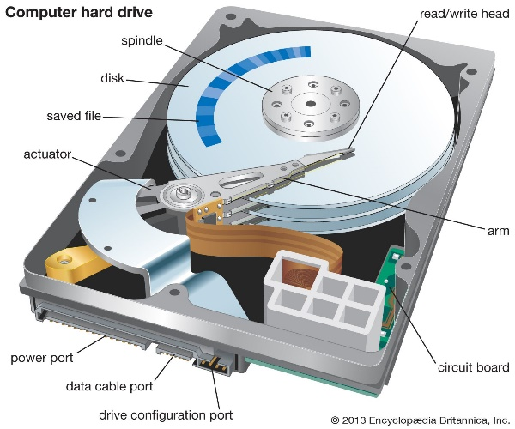**Hard Disk Drive (HDD**), hard disk, hard drive, or fixed disk, is an electro-mechanical data storage device that stores and retrieves digital data using magnetic storage with one or more rigid rapidly rotating platters coated with magnetic material. The platters are paired with magnetic heads, usually arranged on a moving actuator arm, which read and write data to the platter surfaces. Data is accessed in a random-access manner, meaning that individual blocks of data can be stored and retrieved in any order. HDDs are a type of non-volatile storage, retaining stored data when powered off. Modern HDDs are typically in the form of a small rectangular box.

<https://en.wikipedia.org/wiki/Hard_disk_drive>

# LightboxI/O

**Input/Output (I/O**, i/o, or informally io or IO) is the communication between an information processing system, such as a computer, and the outside world, possibly a human or another information processing system. Inputs are the signals or data received by the system and outputs are the signals or data sent from it. The term can also be used as part of an action; to "perform I/O" is to perform an input or output operation.

<https://en.wikipedia.org/wiki/Input/output>

(Input/Output port) An I/O port is a socket on a computer that a cable is plugged into. The port connects the CPU to a peripheral device via a hardware interface or to the network via a network interface. See port, standards - hardware interfaces, DisplayPort, HDMI and USB.

<https://www.pcmag.com/encyclopedia/term/io-port>

# AI

**Artificial intelligence (AI)** is intelligence—perceiving, synthesizing, and inferring information—demonstrated by machines, as opposed to intelligence displayed by humans or by other animals. Example tasks in which this is done include speech recognition, computer vision, translation between (natural) languages, as well as other mappings of inputs.

<https://en.wikipedia.org/wiki/Artificial_intelligence>

**Artificial Intelligence** Devices and applications that exhibit human intelligence and behavior, including robots, self-driving cars, medical diagnosis and the ever-improving areas of voice, face and natural language recognition. Virtually every industry from finance to agriculture is using or exploring AI to improve operations and decision making.

<https://www.pcmag.com/encyclopedia/term/ai>

# WAN

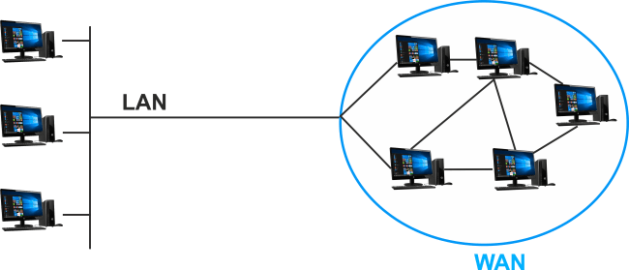

**Wide Area Network** A long-distance communications network that covers a wide geographic area, such as a state or country. The telephone companies and cellular carriers deploy WANs to service large regional areas or the entire nation. Large enterprises have their own private WANs to link remote offices, or they use the Internet for connectivity. Of course, the Internet is the world's largest WAN.

<https://www.pcmag.com/encyclopedia/term/wan>

**Wide Area Network** (WAN) is a telecommunications network that extends over a large geographic area. Wide area networks are often established with leased telecommunication circuits

<https://en.wikipedia.org/wiki/Wide_area_network>

# TCP/IP

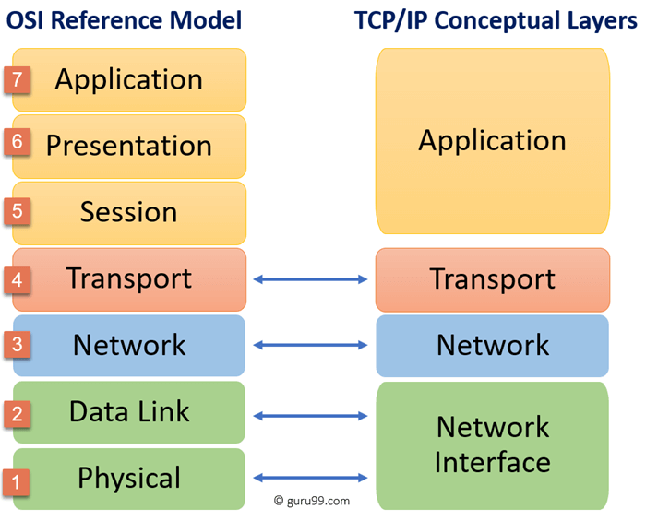**Transmission Control Protocol/Internet Protocol** The global standard networking protocol. TCP/IP was developed in the 1970s for the U.S. military's ARPAnet, the world's first packet-switched network. It was created to enable all types of computers to transmit data to each other via a common format and language and even withstand disruption in the event of war. Vinton Cerf and Bob Kahn were major contributors (see IP on Everything). See ARPAnet and TCP/IP abc's.

<https://www.pcmag.com/encyclopedia/term/tcpip>

**Internet protocol suite,** commonly known as TCP/IP, is a framework for organizing the set of communication protocols used in the Internet and similar computer networks according to functional criteria. The foundational protocols in the suite are the Transmission Control Protocol (TCP), the User Datagram Protocol (UDP), and the Internet Protocol (IP). Early versions of this networking model were known as the Department of Defense (DoD) model because the research and development were funded by the United States Department of Defense through DARPA.

<https://en.wikipedia.org/wiki/Internet_protocol_suite>

# SLA

**Service Level Agreement** A contract between the provider and the user that specifies the level of service expected during its term. SLAs are used by vendors and customers as well as internally by IT shops and their end users. They can specify bandwidth availability, response times for routine and ad hoc queries, response time for problem resolution (network down, machine failure, etc.) as well as attitudes and consideration of the technical staff.

<https://www.pcmag.com/encyclopedia/term/SLA>

# What is AWS – Introduction to Amazon Web Services ComponentsAWS

**Amazon Web Services.** A variety of cloud-based services from Amazon.com that developers use to deploy Web applications. Launched in 2002, the most notable Amazon Web Services (AWS) are its computing and storage offerings (see EC2 and S3 cloud storage). Amazon is the largest cloud computing provider.

In 2011, Amazon added a supercomputing service, offering a cluster of computers for performing intensive calculations (see Amazon Bracket). Amazon Web Services is a huge and very profitable business for the company. See Mechanical Turk, cloud computing and Amazon.com.

<https://www.pcmag.com/encyclopedia/term/amazon-web-services>

# DBMS

**DataBase Management System** Software that controls the organization, storage, retrieval, security and integrity of data in a database. It accepts requests from the application and instructs the operating system to transfer the appropriate data. The major DBMS vendors are Oracle, IBM, Microsoft and Sybase (see Oracle Database, DB2, SQL Server and ASE). MySQL and SQLite are very popular open source products (see MySQL and SQLite).

A DBMS interfaces with applications written in traditional programming languages (C/C++, Java, etc.), and it may include its own programming language. Following are the major features of a DBMS.

<https://www.pcmag.com/encyclopedia/term/dbms>

# A Look at the Differences Between SSD and HDDSSD

**Solid State Drive** An all-electronic, non-volatile storage drive. SSDs are the internal storage in smartphones, tablets and most laptop computers and are increasingly used instead of hard drives in desktop computers. Emerging in the late 1990s, SSDs are faster than hard drives because there is no moving read/write head (zero latency). Without SSDs, smartphones and tablets would never have flourished. As of 2023, there are several dozen manufacturers of SSDs using the SATA or NVMe interface and starting at 128GB. The largest SSD is Seagate's 60TB drive, which uses the SAS interface (see serial attached SCSI). See SATA and NVMe.

<https://www.pcmag.com/encyclopedia/term/ssd>

# SaaS

**Software-As-A-Service** Software that is rented rather than purchased. Instead of buying applications and paying for periodic upgrades, SaaS is subscription based, and upgrades are automatic during the subscription period. When that expires, the software is no longer valid; for example, see Microsoft 365.

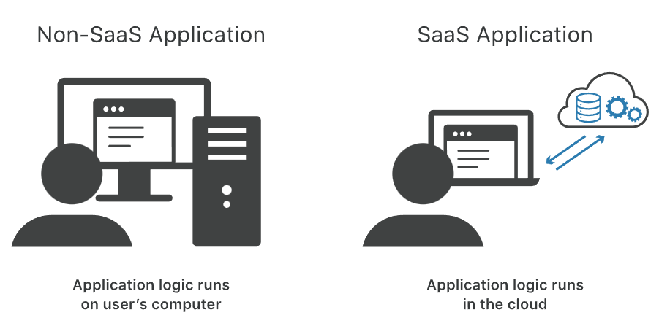

<https://www.pcmag.com/encyclopedia/term/saas>

# GHz

**GigaHertZ** One billion cycles per second. High-speed computers have internal clocks rated in GHz, and radio frequency applications transmit in this range. For an explanation of how GHz and MHz affect computer performance, see MHz. See RF and space/time.

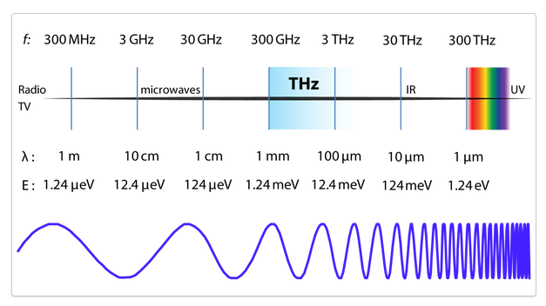

<https://www.pcmag.com/encyclopedia/term/ghz>

# GUID

**Globally Unique Identifier**, an implementation of the universally unique ID (see UUID) that is computed by Windows and Windows applications. Using a pseudo-random 128-bit number, GUIDs are used to identify user accounts, documents, software, hardware, software interfaces, sessions, database keys and other items.

First developed to keep track of instances of COM objects, GUIDs were created by an algorithm that used the MAC address of the local Ethernet card. Microsoft later dropped the Ethernet address due to protests that documents could be traced back to a particular user's machine. Following are common Microsoft GUIDs.

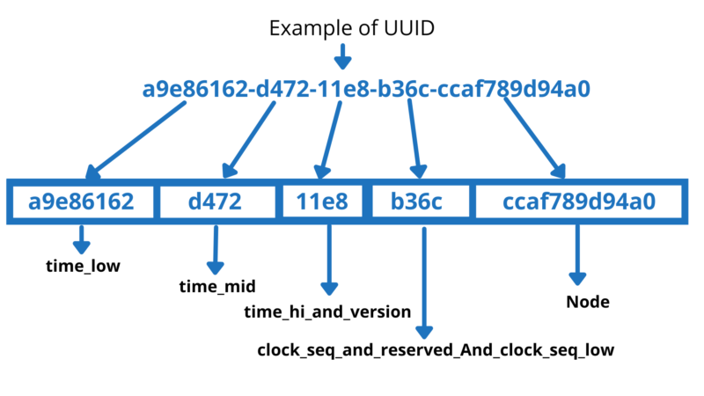

<https://www.pcmag.com/encyclopedia/term/guid>

# C2C

**Client to Client**, an earlier term for peer-to-peer (P2P), in which one user communicates with another user without going through a server in between. See peer-to-peer and X2X.

**Customer to Customer**, a website such as eBay or PayPal, in which a user negotiates a business transaction with another user.



<https://www.pcmag.com/encyclopedia/term/c2c>

# Business-to-Business (B2B) | KOSS.Lexikon | KOSS GCI SoftwareB2B

Business-to-business (B2B or, in some countries, BtoB) is a situation where one business makes a commercial transaction with another. This typically occurs when:

* A business is sourcing materials for their production process for output (e.g., a food manufacturer purchasing salt), i.e. providing raw material to the other company that will produce output.
* A business needs the services of another for operational reasons (e.g., a food manufacturer employing an accountancy firm to audit their finances).
* A business re-sells goods and services produced by others (e.g., a retailer buying the end product from the food manufacturer).

<https://en.wikipedia.org/wiki/Business-to-business>

# IoT

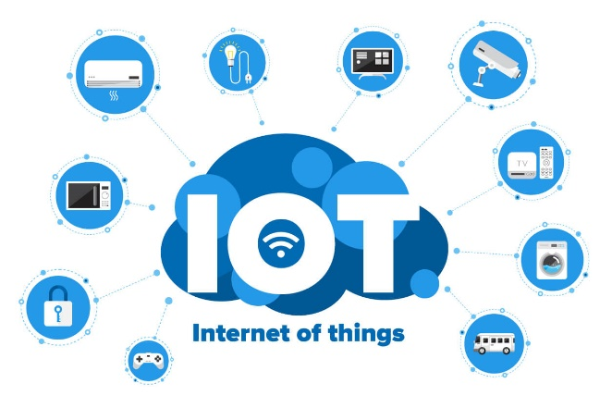**Internet Of Things,** connecting the physical world to a computer or mobile device via the Internet. Also called the "Internet of Everything" (IoE), the Internet of Things includes home appliances, door locks, doorbells, thermostats, lighting, sleep monitors, security cameras, fitness bands, as well as sensors for traffic monitoring. It is estimated that there will be trillions of IoT devices in the future.

<https://www.pcmag.com/encyclopedia/term/IoT>

**Internet of things (IoT)** describes physical objects (or groups of such objects) with sensors, processing ability, software and other technologies that connect and exchange data with other devices and systems over the Internet or other communications networks. Internet of things has been considered a misnomer because devices do not need to be connected to the public internet, they only need to be connected to a network, and be individually addressable.

<https://en.wikipedia.org/wiki/Internet_of_things>

# IaaS

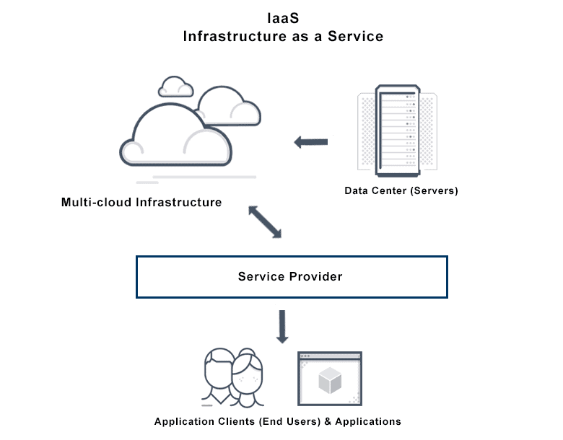**Infrastructure As A Service,** a cloud computing service that provides a basic computing platform, typically the hardware and virtual machine (VM) infrastructure (no operating system) or the hardware and an operating system.

<https://www.pcmag.com/encyclopedia/term/iaas>

Infrastructure as a service (IaaS) is a cloud computing service model by means of which computing resources are supplied by a cloud services provider. The IaaS vendor provides the storage, network, servers, and virtualization (which mostly refers, in this case, to emulating computer hardware). This service enables users to free themselves from maintaining an on-premises data center.[1] The IaaS provider is hosting these resources in either the public cloud (meaning users share the same hardware, storage, and network devices with other users), the private cloud (meaning users do not share these resources), or the hybrid cloud (combination of both)

<https://en.wikipedia.org/wiki/Infrastructure_as_a_service>

# APC Smart-UPS C SMC1500C - onduleur - 900-watt - 1440 VA - avec APC SmartConnect 1UPS

**Uninterruptible Power Supply**, a device that provides battery backup when the electrical power fails or drops to an unacceptable voltage level. Small UPS systems provide power for a few minutes; enough to power down the computer in an orderly manner, while larger systems have enough battery for several hours. In mission critical datacenters, UPS systems are used for just a few minutes until electrical generators take over.

UPS systems can be set up to alert file servers to shut down in an orderly manner when an outage has occurred, and the batteries are running out.

<https://www.pcmag.com/encyclopedia/term/UPS>

# BPS

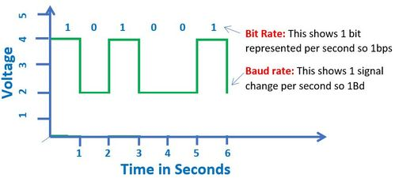

**Bits Per Second,** the measurement of the speed of data transfer in a communications system.

<https://www.pcmag.com/encyclopedia/term/bps>

Bit Rate (bitrate or as a variable R) is the number of bits that are conveyed or processed per unit of time. The bit rate is expressed in the unit bit per second (symbol: bit/s), often in conjunction with an SI prefix such as kilo (1 kbit/s = 1,000 bit/s), mega (1 Mbit/s = 1,000 kbit/s), giga (1 Gbit/s = 1,000 Mbit/s) or tera (1 Tbit/s = 1,000 Gbit/s).[2] The non-standard abbreviation bps is often used to replace the standard symbol bit/s, so that, for example, 1 Mbps is used to mean one million bits per second.

<https://en.wikipedia.org/wiki/Bit_rate>

# USB

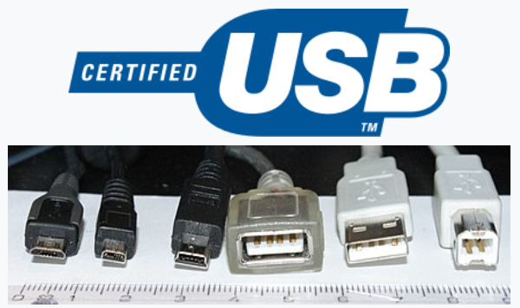

**Universal Serial Bus (USB)** is an industry standard that specifies the physical interfaces and protocols for connecting, data transferring and powering of hosts, such as personal computers, peripherals, e.g. keyboards and mobile devices, and intermediate hubs. USB was designed to standardize the connection of peripherals to computers, replacing various interfaces such as serial ports, parallel ports, game ports, and ADB ports. It has become commonplace on a wide range of devices, such as keyboards, mice, cameras, printers, scanners, flash drives, smartphones, game consoles, and power banks.

<https://en.wikipedia.org/wiki/USB>

# FTP

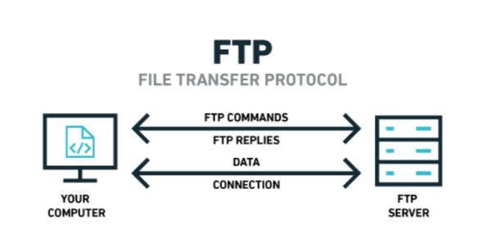

**File Transfer Protocol,** a protocol used to transfer files over an IP network. For example, after developing the HTML pages for a website on a local machine, they are typically uploaded to the Web server using FTP.

FTP includes functions to log in to the network, list directories and copy files. It can also convert between the ASCII and EBCDIC character codes. FTP operations can be performed by typing commands at a command prompt or via an FTP utility running under a graphical interface such as Windows. FTP transfers can also be initiated from within a Web browser by entering the URL preceded with ftp://.

<https://www.pcmag.com/encyclopedia/term/ftp>

# CSS - WikipediaCSS

**Cascading Style Sheets (CSS)** is a style sheet language used for describing the presentation of a document written in a markup language such as HTML or XML (including XML dialec ts such as SVG, MathML or XHTML). CSS is a cornerstone technology of the World Wide Web, alongside HTML and JavaScript.

<https://en.wikipedia.org/wiki/CSS>

# VPN

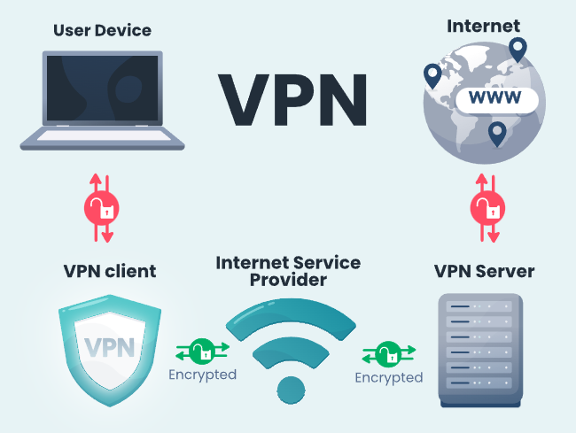**Virtual Private Network (VPN)** is a mechanism for creating a secure connection between a computing device and a computer network, or between two networks, using an insecure communication medium such as the public Internet.

A VPN can extend a private network (one that disallows or restricts public access), in such a way that it enables users of that network to send and receive data across public networks as if the public networks' devices were directly connected to the private network. The benefits of a VPN include security, reduced costs for dedicated communication lines, and greater flexibility for remote workers. VPNs are also used to bypass internet censorship. Encryption is common, although not an inherent part of a VPN connection.

<https://en.wikipedia.org/wiki/Virtual_private_network>

# ASCII

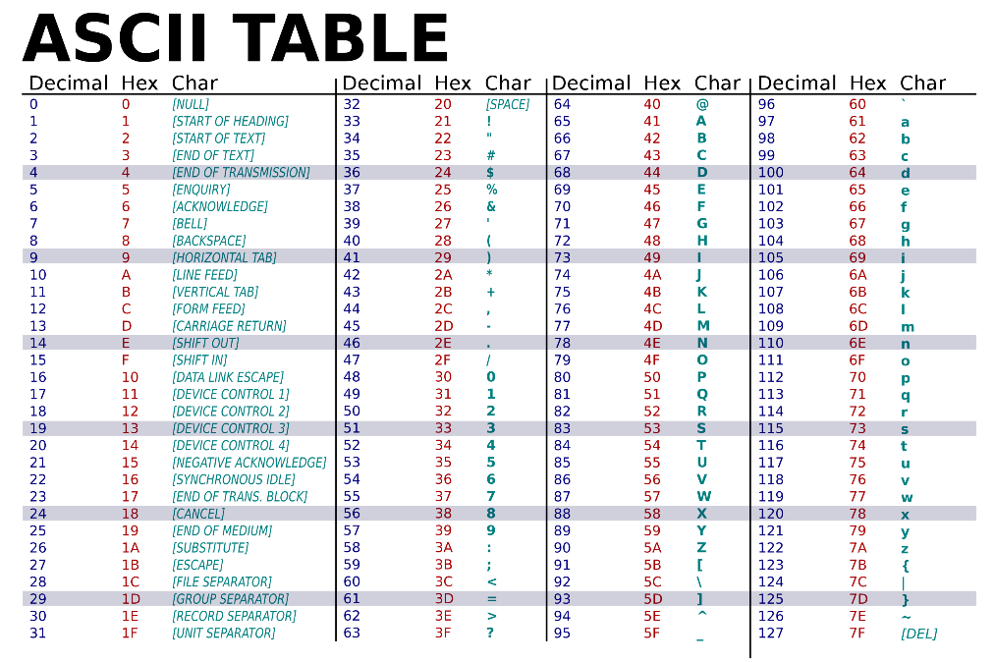

**American Standard Code for Information Interchange**, is a character encoding standard for electronic communication. ASCII codes represent text in computers, telecommunications equipment, and other devices. Because of technical limitations of computer systems at the time it was invented, ASCII has just 128 code points, of which only 95 are printable characters, which severely limited its scope. Many computer systems instead use Unicode, which has millions of code points, but the first 128 of these are the same as the ASCII set.

<https://en.wikipedia.org/wiki/ASCII>

# VOIP

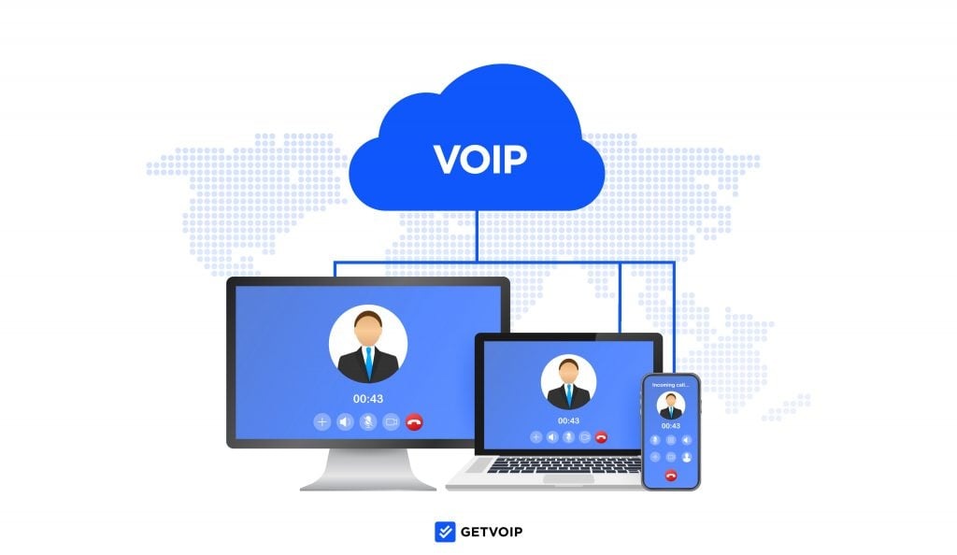**Voice Over IP**, a digital telephone service that uses the Internet for transport, as well as private IP networks. "IP" stands for "Internet Protocol." In order that calls can originate and terminate from regular telephones, connections to the public telephone network (PSTN) are also provided. Telephone companies, cable companies and dedicated providers offer VoIP calling for a fixed monthly fee or low per-minute charge. Customers must have Internet access.

<https://www.pcmag.com/encyclopedia/term/voip>

# Take advantage of all the benefits of Office 365 with personalized trainingO365

**Microsoft 365 (Office 365)** is the productivity cloud designed to help each of us achieve what matters, in our work and life, with best-in-class Office apps, intelligent cloud services, and advanced security.

<https://www.microsoft.com/en-ca/microsoft-365/business/compare-all-microsoft-365-business-products-b>

# FAQ



**Frequently Asked Questions (FAQ)** list is often used in articles, websites, email lists, and online forums where common questions tend to recur, for example through posts or queries by new users related to common knowledge gaps. The purpose of a FAQ is generally to provide information on frequent questions or concerns; however, the format is a useful means of organizing information, and text consisting of questions and their answers may thus be called a FAQ regardless of whether the questions are actually frequently asked.

<https://en.wikipedia.org/wiki/FAQ>

# MFA

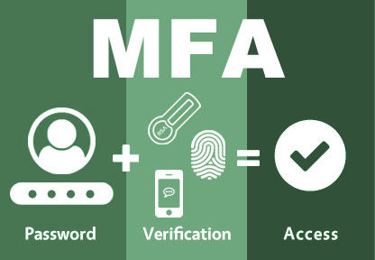**Multi-Factor Authentication (MFA**; encompassing two-factor authentication, or 2FA, along with similar terms) is an electronic authentication method in which a user is granted access to a website or application only after successfully presenting two or more pieces of evidence (or factors) to an authentication mechanism: knowledge (something only the user knows), possession (something only the user has), and inherence (something only the user is). MFA protects user data—which may include personal identification or financial assets—from being accessed by an unauthorized third party that may have been able to discover, for example, a single password.

<https://en.wikipedia.org/wiki/Multi-factor_authentication>

# DNS

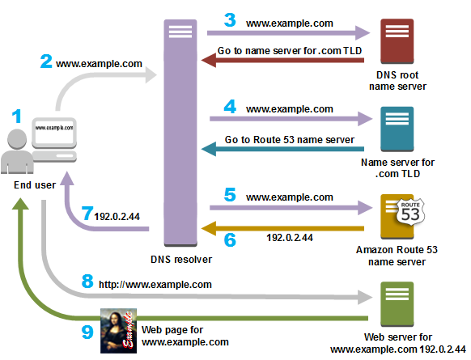**Domain Name System (DNS)**  is a hierarchical and distributed naming system for computers, services, and other resources in the Internet or other Internet Protocol (IP) networks. It associates various information with domain names assigned to each of the associated entities. Most prominently, it translates readily memorized domain names to the numerical IP addresses needed for locating and identifying computer services and devices with the underlying network protocols.

<https://en.wikipedia.org/wiki/Domain_Name_System>

# GPS

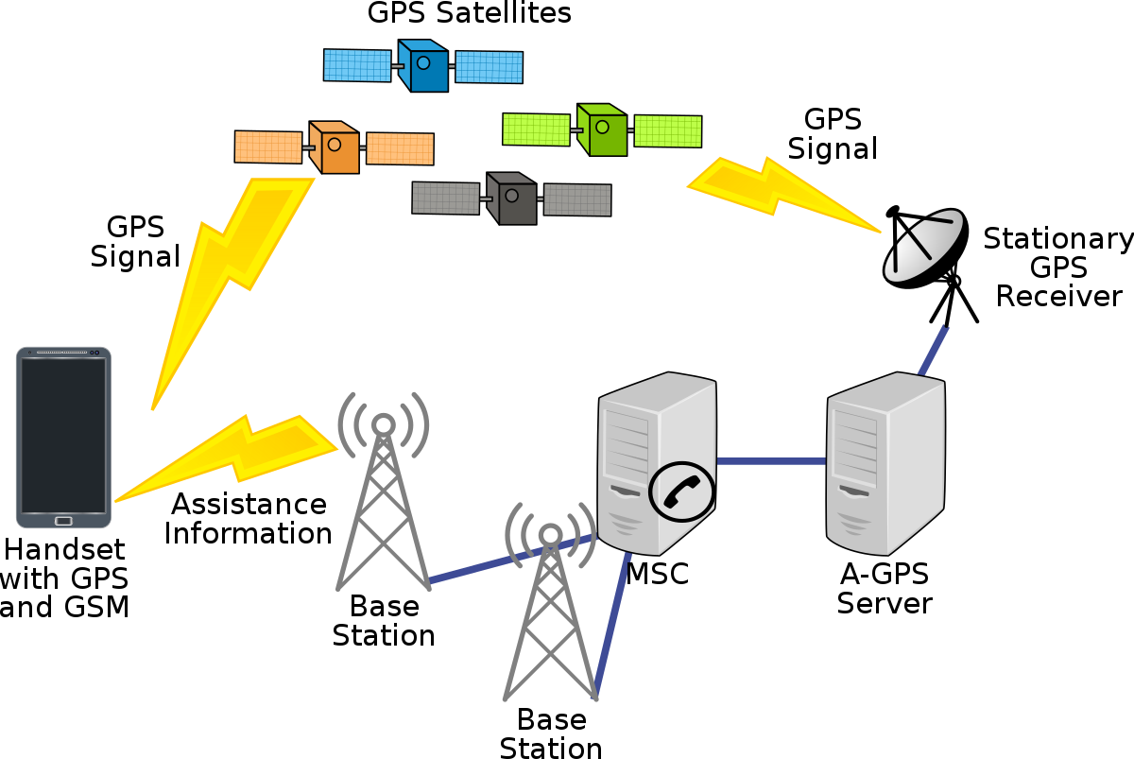

**Global Positioning System (GPS),** originally Navstar GPS, is a satellite-based radio navigation system owned by the United States government and operated by the United States Space Force. It is one of the global navigation satellite systems (GNSS) that provides geolocation and time information to a GPS receiver anywhere on or near the Earth where there is an unobstructed line of sight to four or more GPS satellites. It does not require the user to transmit any data, and operates independently of any telephonic or Internet reception, though these technologies can enhance the usefulness of the GPS positioning information. It provides critical positioning capabilities to military, civil, and commercial users around the world. Although the United States government created, controls and maintains the GPS system, it is freely accessible to anyone with a GPS receiver.

<https://en.wikipedia.org/wiki/Global_Positioning_System>

# Network card.jpgNIC

**Network Interface Controller (NIC**, also known as a network interface card, network adapter, LAN adapter or physical network interface, and by similar terms) is a computer hardware component that connects a computer to a computer network.

<https://en.wikipedia.org/wiki/Network_interface_controller>

# W3C



**World Wide Web Consortium (W3C)** is the main international standards organization for the World Wide Web. Founded in 1994 and led by Tim Berners-Lee, the consortium is made up of member organizations that maintain full-time staff working together in the development of standards for the World Wide Web. As of 5 March 2023, W3C had 462 members. W3C also engages in education and outreach, develops software and serves as an open forum for discussion about the Web.

<https://en.wikipedia.org/wiki/World_Wide_Web_Consortium>

# PaaS

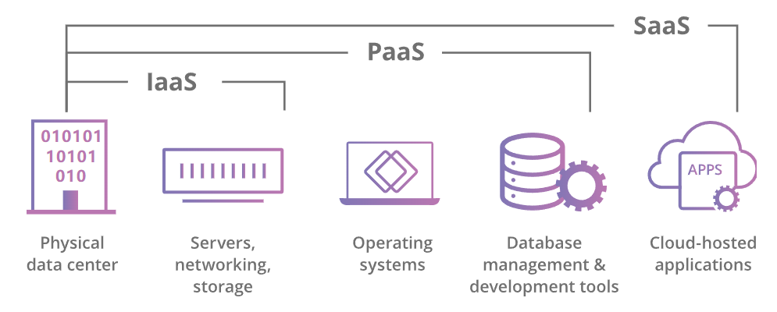

**Platform as a service (PaaS)** or application platform as a service (aPaaS) or platform-based service is a category of cloud computing services that allows customers to provision, instantiate, run, and manage a modular bundle comprising a computing platform and one or more applications, without the complexity of building and maintaining the infrastructure typically associated with developing and launching the application(s), and to allow developers to create, develop, and package such software bundles.

<https://en.wikipedia.org/wiki/Platform_as_a_service>

# VM

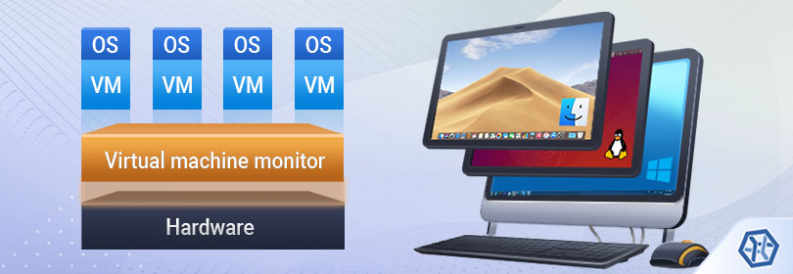

**Virtual Machine (VM)** is the virtualization or emulation of a computer system. Virtual machines are based on computer architectures and provide the functionality of a physical computer. Their implementations may involve specialized hardware, software, or a combination of the two.

<https://en.wikipedia.org/wiki/Virtual_machine>

# WAP

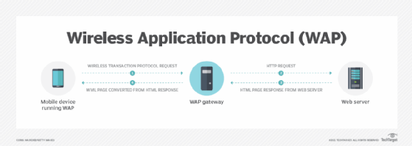

**Wireless Application Protocol,** a standard for providing cellphones, pagers and other handhelds with secure access to email and text-based Web pages. Introduced in 1997 by Phone.com, Ericsson, Motorola and Nokia, WAP provides an environment for wireless applications that includes a wireless version of TCP/IP and a framework for telephony integration such as call control and phone book access. Supporting keypad and voice recognition, WAP is independent of the air interface and runs over all major wireless networks. It is also device independent and can be used in any mobile device.

<https://www.pcmag.com/encyclopedia/term/WAP>

# CSV

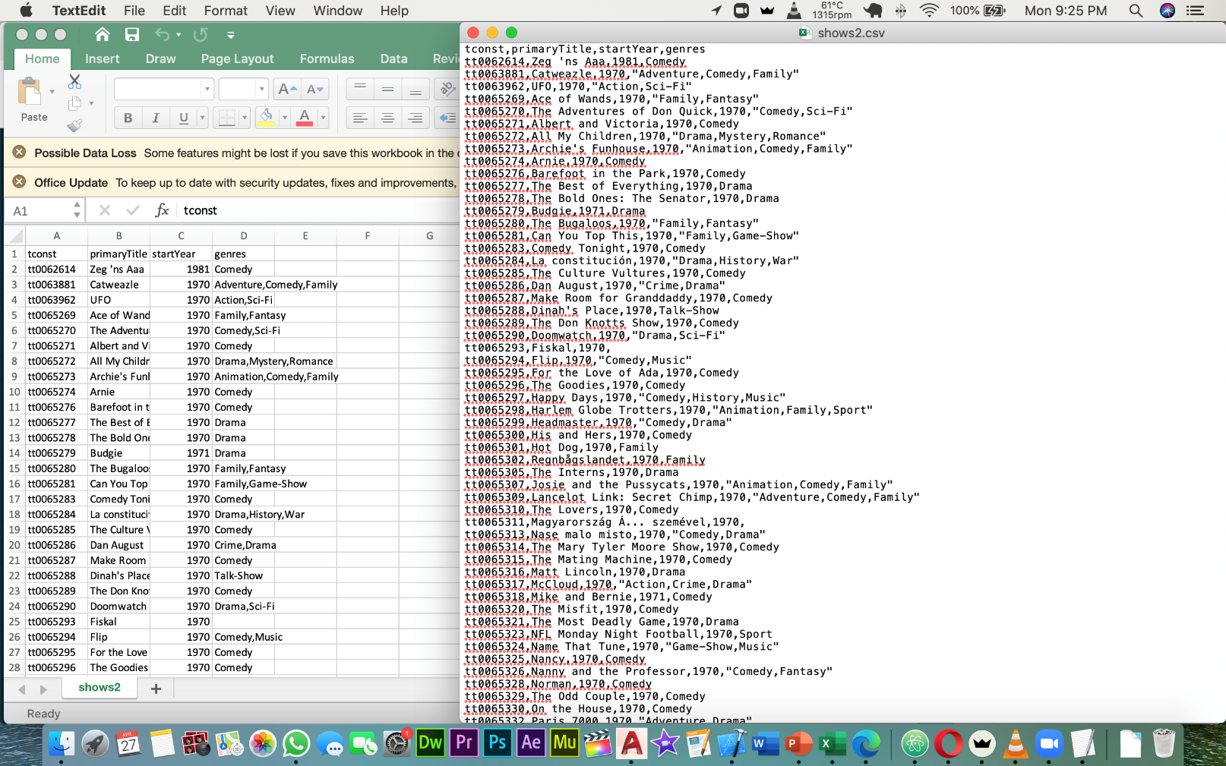

**Comma Separated Values,** also called "comma delimited," CSV is a text-based data format that separates fields with a comma and ends with a line break (although a few implementations support line breaks within the record). Widely used as a data exchange format, spreadsheets as well as many other business applications can read and write comma delimited files. The text may be surrounded with quotes as follows.

<https://www.pcmag.com/encyclopedia/term/csv>

# What is JSON? - YouTubeJSON

**JSON (JavaScript Object Notation)** is an open standard file format and data interchange format that uses human-readable text to store and transmit data objects consisting of attribute–value pairs and arrays (or other serializable values). It is a common data format with diverse uses in electronic data interchange, including that of web applications with servers.

JSON is a language-independent data format. It was derived from JavaScript, but many modern programming languages include code to generate and parse JSON-format data. JSON filenames use the extension .json.

<https://en.wikipedia.org/wiki/JSON>

# Example 1: Read XML FileXML

Extensible Markup Language (XML) is a markup language and file format for storing, transmitting, and reconstructing arbitrary data. It defines a set of rules for encoding documents in a format that is both human-readable and machine-readable. The World Wide Web Consortium's XML 1.0 Specification of 1998 and several other related specifications—all of them free open standards—define XML.

<https://en.wikipedia.org/wiki/XML>